**Lab#7:**

**Objective:** To Understand Multithreading.

**Task#1:** Write the same code for matrix multiplication and divide the code into ten threads. Also note the timestamp at the start and end of the program. Give your conclusion.

**Matrix Multiplication Without Threading:**

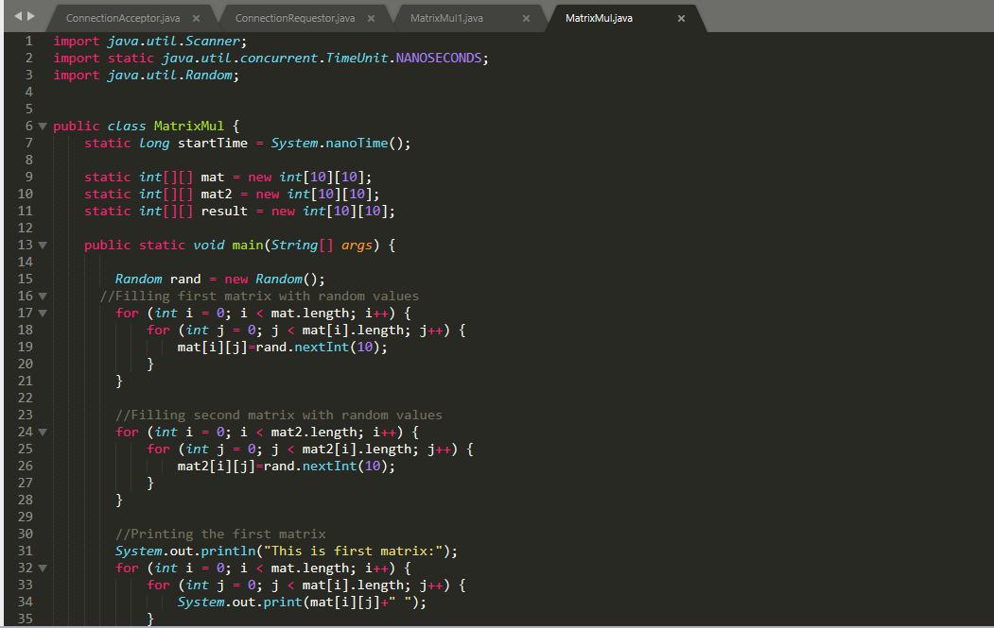

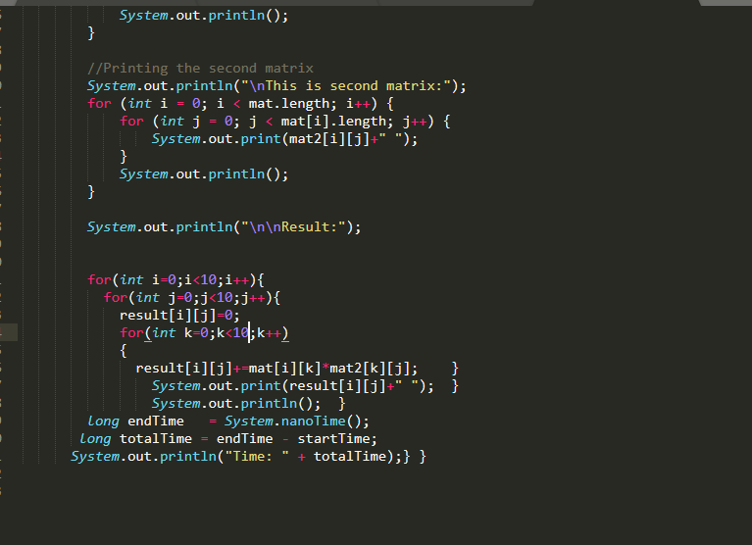

**Result:**

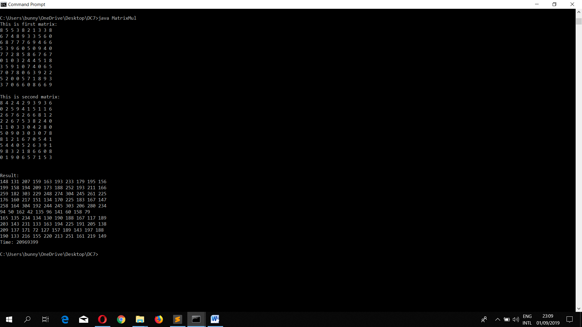

**Matrix Multiplication With Threading:**

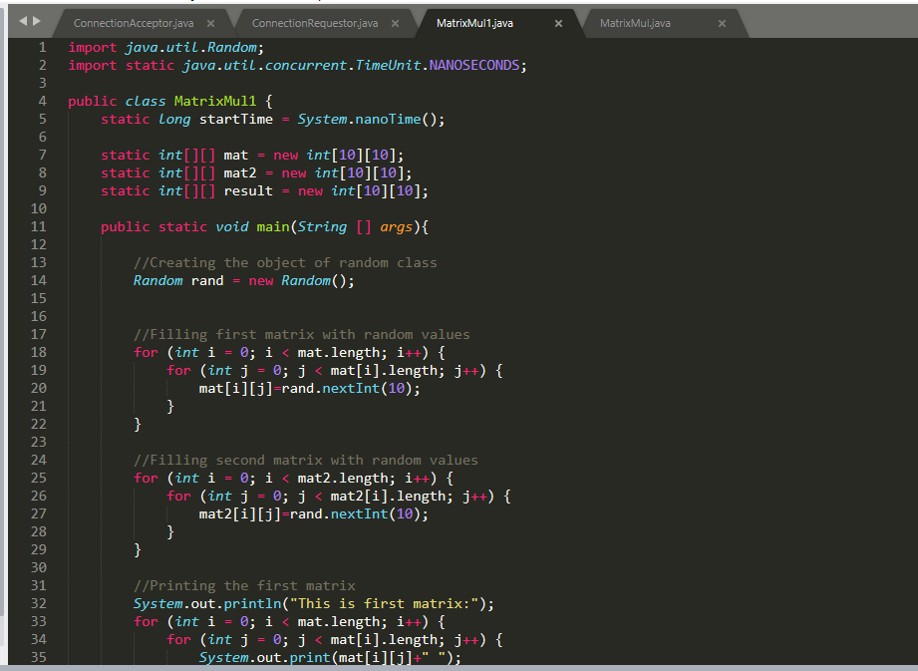

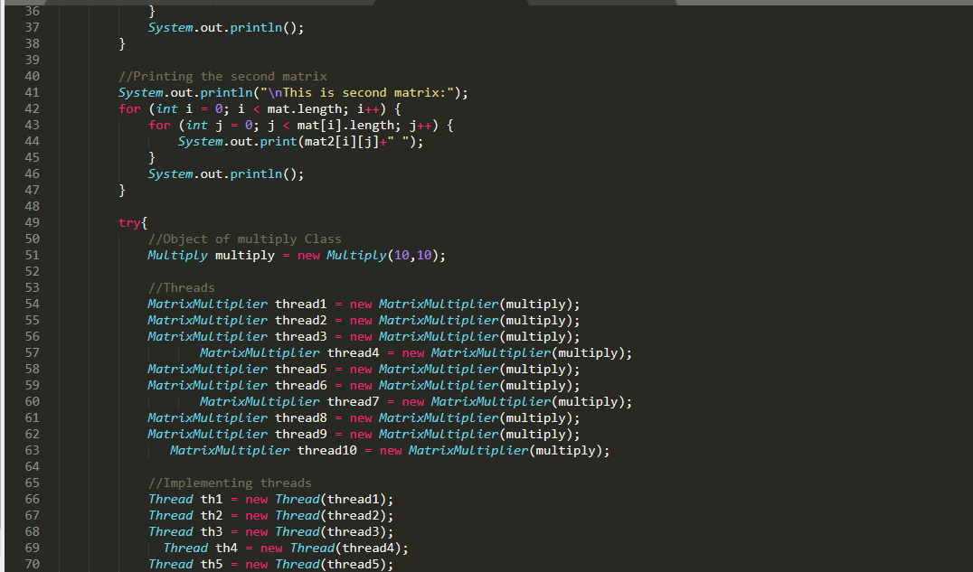

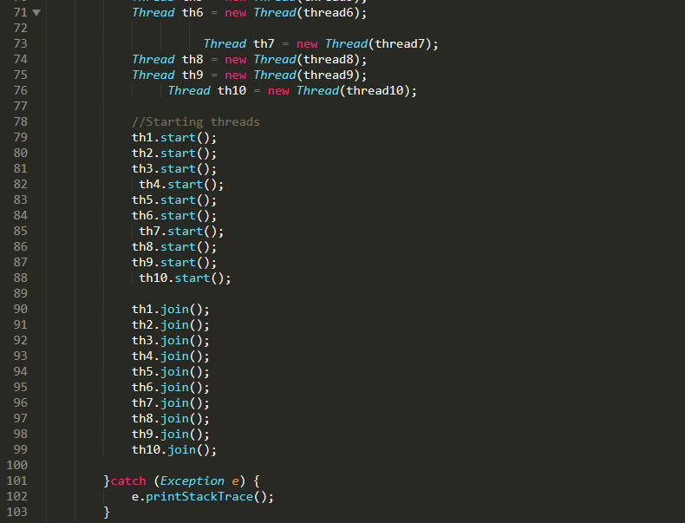

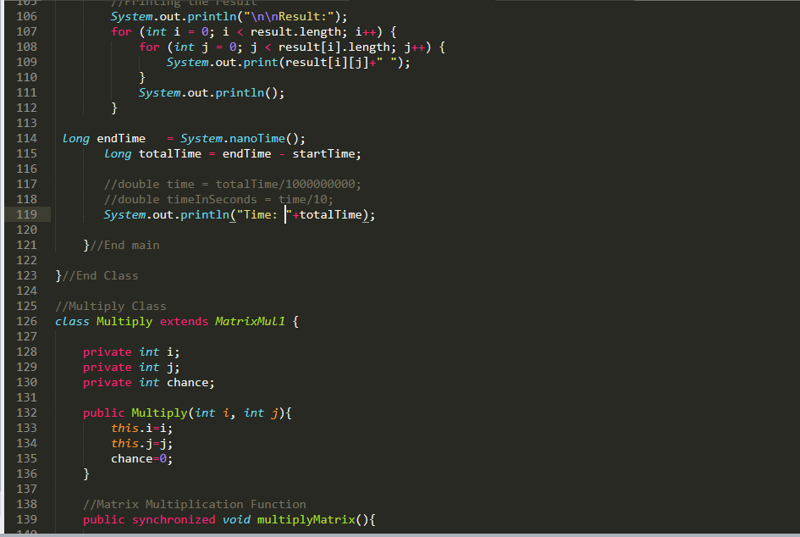

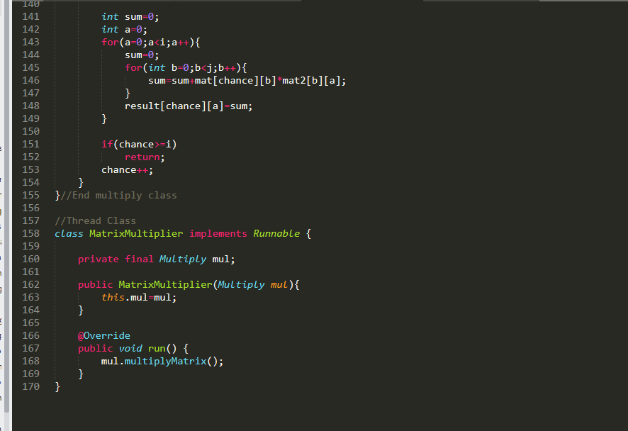

**Result:**

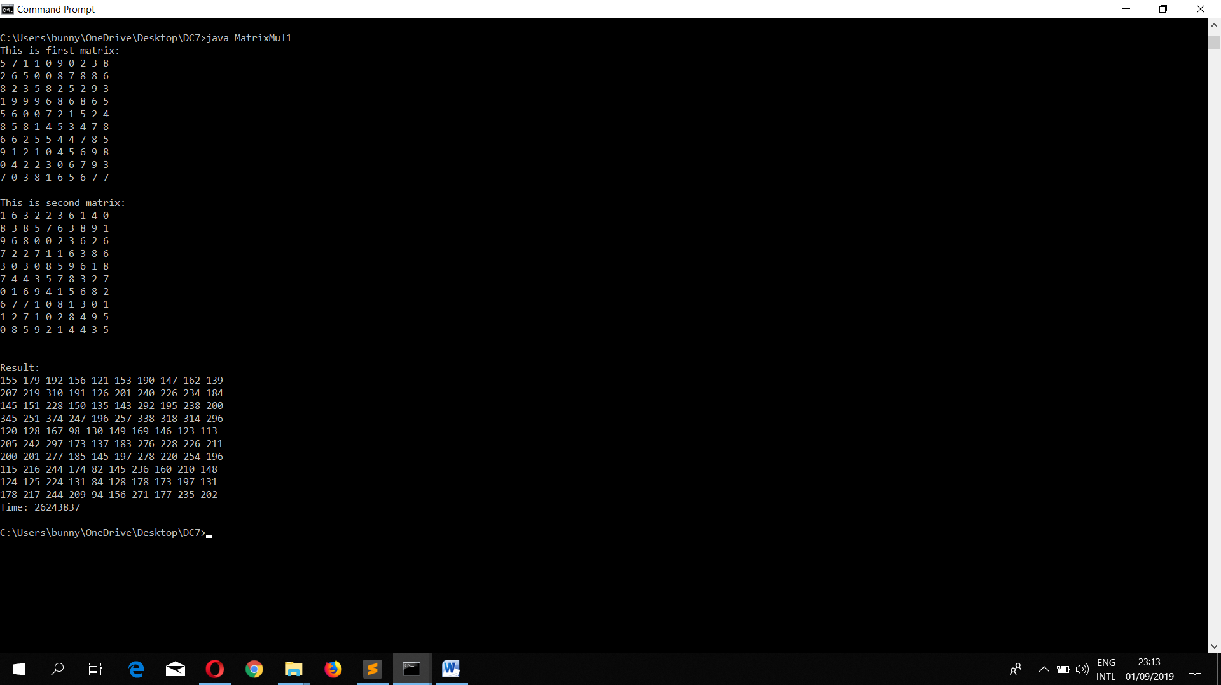

**Conclusion:** The total time of completion of matrix multiplication using threading is 36630891 neno second and total time of matrix multiplication without threading is 34770753 neno second so time without threading matrix multiplication take less time.